|  |
| --- |
| universiti of west london |
| Engineering Application |
| Assignment 1 |
|  |
| **Manuel Alberto SuenaGalindez** |
| **22/12/2017** |

|  |
| --- |
|  |

Table of Content

Introduction 3

Aim and Objectives 3

Procedure 3

List of Equipment: 3

Circuit Description and OrCAD Diagram 4

Results: 5

# Introduction

For this assignment the task was to build a veroboard circuit by following the instructions given in handout sheets that were received at the beginning of the semester. In these sheets there was a veroboard layout for the first of three circuits that had to be built ,and the step that were to follow during the testing of this 3 circuit ,the other two circuits didn’t have veroboard layout instead they had a OrCAD layout from which we had to design our on veroboard layout to build the circuit. After all the circuits were built and tested. The results were presented and discussed in a report with a OrCAD layout of each circuit designed

## Aim and Objectives

The purpose of this assignment was to obtain experience using OrCAD, learning to design veroboard circuit layout, learning how to use testing equipment and the basic skills that are needed going forward into this course, such as soldering. With obtained skills students are able to design a circuit in OrCAD and in veroboard layout, build it and verify with the test equipment that the circuit is working as designed.

# Procedure

For this practical laboratory the students had to follow a list of test to be performed on each circuit so to verified that the circuit was working as designed. The first step that has to be done for every circuit, after soldering all components to the veroboard , is to use the multimeter to check for short circuits by placing the probe tips in to different lines close to each other and checking for unwanted connections.

In the first circuit, after checking for short circuits, the testing would continue by connecting the circuit to the power supply at 9V, then by using the PSU to check for any unusual high currents or short circuits. Afterwards, the opamp and the MIC_out pin are checked to ensure that both are being powered by the power supply. Then, the test would continue by connecting the output to the oscilloscope while the PSU is on to get amplified sine wave .

In the circuit 2 after designing the layout and building the circuit without soldering the capacitor C2 on the board, the Oscilloscope and the signal generator, setup at 2V and peak to peak frequency of 1khz, are used to observe the difference of signal wave shown on the Oscilloscope display when the C2 capacitor is connected and when is not.

In circuit 3, after designing and building the board, it is necessary to make sure of the correct position allocation of each LED with the first six being green LEDs, the seventh and the eighth being yellow and the last two red. Later, the power supply is used and setup at 9V to check if the IC power pin is receiving the supply voltage, then by connecting a second power supply, setup at 0V, to the SIG and by gradually increasing the supply voltage so as to record the voltage at which each LED lights up and plot a curve of it.

## List of Equipment:

* Oscilloscope TDS2002B serial No 337310
* Power Supply EX354RT serial No 330334
* Signal Generator TG330 serial No3303760
* Digital Multimeter

Circuit Description and OrCAD Diagram

Figure 1 is a microphone amplifier. In this circuit an analog signal is received by the MIC_in pin which is then transmitted and received by the 3 pin of the opamp. Then, the signal is amplified by the opamp and send as an output analog signal by the pin 6 of the opamp, which is then received by the MIC_out pin.



Figure

Figure 2 is a peak detector that allows to maintain for a short period of time the peak voltage signal received by the microphone amplifier so the signal can be properly displayed by the LED display



Figure

Figure 3 is a LED display. This LED display is able to measure analog voltage and by driving 10 LED is able to provide a logarithmic display with a differs of 3dB between each LED. By using LM3915 display driver is able to operate in to modes dot display or bar graph.



Figure

# Results

Figure 4 shows the waveform recorded result for the first circuit the microphone amplifier. From figure 4 it is possible to observe that the signal is been received by the MIC_out pin. It was observed during the testing of this circuit that sometimes the signal was not been received by the MIC_out pin. This may have been caused by wrongly setup equipment or damage to the components during storage, such as unwanted broken tracks caused by chafing with other boards and components that come out of the board or that have broken connections.

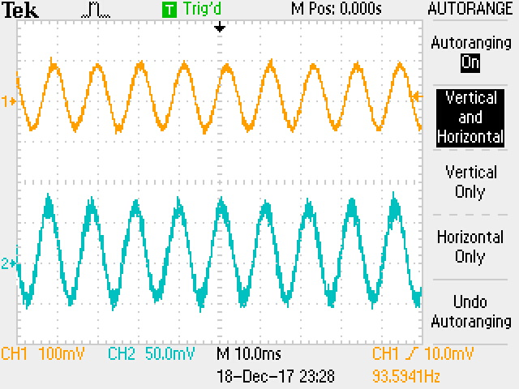

Figure

Figure 5 and figure 6 show the waveform recorded result for the second circuit, the peak detector. Figure 5 shows the circuit without the C2 capacitor, which can be noted from the behaviour of the wave of the signal output that is the same as signal input ,and figure 6 shows the circuit with the capacitor C2. In this figure we can see that the signal wave show the peak voltage of the signal wave

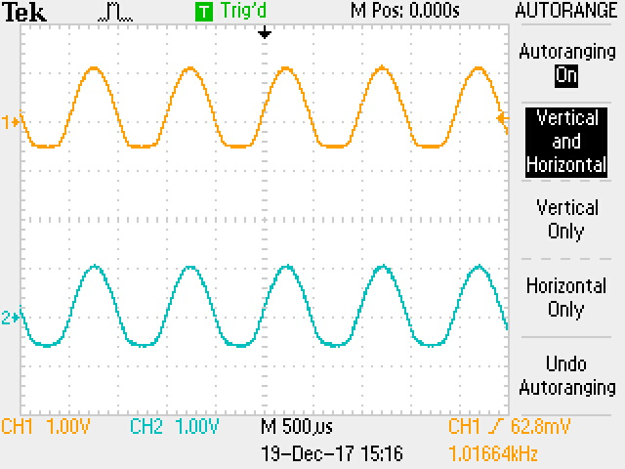

Figure

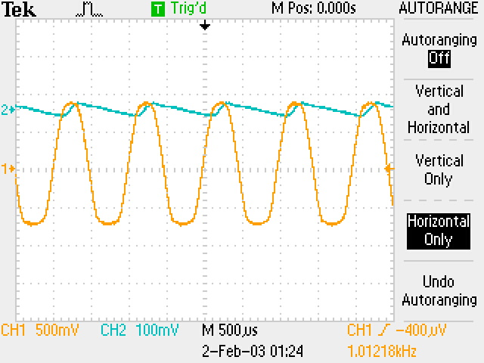

Figure